Objects
Objects can be created in two ways
- let obj = new Object(); // Object constructor syntax
- let obj = {}; // Object literal Syntax

The objects store data as pairs, each pair contains a key and value.

Adding properties into an object :
Obj.isAdmin = true;

Note: The key should be a string and value can be of any type.

The object properties can be accessed using the dot(.) operator

Eg : let obj={
Name : “Sameer”,
Age : 20,
}
Obj.Name -> Sameer

We can also have a key as multiword but it should be enclosed in quotes-> “user name”
To access these keys we can use [] (square brackets).

Obj[user name] -> sameer;

A variable assigned to a object stores the address of the object.
Object declared as const can be modified.

Cloning Objects:
Shallow Cloning:
Shallow cloning can be done using the Object.assign() function. This clones the object properties that are primitive.
Eg:
let user = {
name: "John",
sizes: {
height: 182,
width: 50
}
};
let clone = Object.assign({}, user);
alert( user.sizes === clone.sizes ); // true, same object
// user and clone share sizes
user.sizes.width = 60; // change a property from one place
alert(clone.sizes.width); // 60, get the result from the other one

Deep Cloning:
Deep cloning can be done using structuredClone() function. This clones even the objects inside the object.
Eg:
let user = {};
// let's create a circular reference:
// user.me references the user itself
user.me = user;

let clone = structuredClone(user);
alert(clone.me === clone); // true

Function properties are not supported by structuredClone() function, hence deep cloning also fails in some cases.

Garbage Collection:
Uses mark and sweep algorithm which works like traversing from the root node to the end and marks all the objects.
Once marked it checks for objects that are not reachable from the root object and the deletes the objects.

Many Algorithms are used to optimize this approach like generational Collection, Incremental Collection, Idle-time Collection.

A function inside an object is called a method.
Eg :
let user = {
name:"Sam",
sayHi: function(){
console.log("Hello");
},
}
This method can be written in short hand. For example,
let user = {
name:"Sam",
sayHi() {
console.log("Hello");
},
}
This Keyword:
The this keyword is used to represent the current instance of the object. We can also directly use the object name instead of this keyword, but it can sometimes lead to error.

const user = {
name : “Sam”,
sayHi : function() {
alert(user.name);
}
};
let admin = user;
user = null;
admin.sayHi(); // This will led to an error.

Always use this keyword to access the variable.

Arrow functions have no “this”, it uses this keyword from the outer context.

Constructor:
Constructor is a special function which is immediately called.
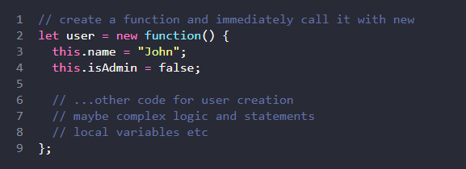
Constructor mode test: new.target

The new.target is mainly used to create a constructor wthout new keyword.
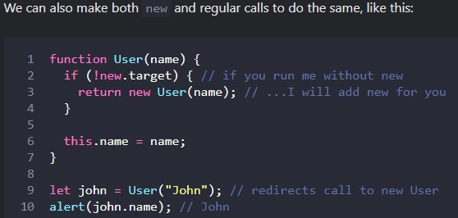

Objects can be called even without parenthesis
We can also create method inside a constructor.
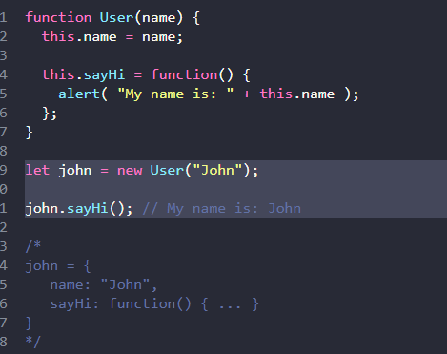
Optional Chaining:
Optional chaining acts as a solution for “property not exist problem”.

Let us say we have to access a street inside the address object, but at 1st we should evaluate whether the address is present in the user object.
In simple terms we can do it like this,
const street = user.address ? user.address : undefined;
But in the above we have to use user.address twice, when it comes to more nested objects the code will be more uglier.
We can use document.querySelector(‘.elem’) as well but this too leads to the same above problem.

To solve this problem, we use optional chaining (?.)
This check the left part 1st, if the left part contains null or undefined, it returns undefined or null. Else it checks all the other parts.
const street = user.address?.street;
The above 1st check the user.address is available then it returns the street.

We can also use optional chaining with function call () and [].
We can also use it for safety deletion.
delete user?.name; // delete user.name if user exists
But we can’t use this for writing.
let user = null;
user?.name = “John” // results in undefined = John;

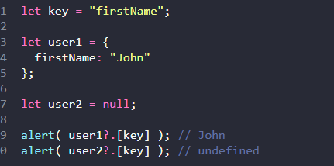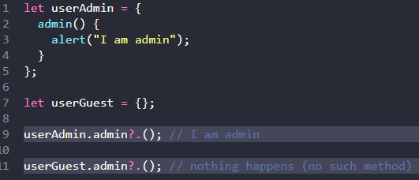

Symbol: (Primitive datatype)
A Symbol is a unique identifier with an optional description.
Even when the descriptions are same, the symbols are unique and symbols will not get auto converted unlike any other data type.

For Eg : alert(1) will be converted to “1”, alert(true) will be converted to “true”
let id = Symbol(“id”)
alert(id) // Type Error
we can convert them by explicitly using .toString() or we can just print it description using alert(id.description).

Hidden Properties in Symbol:
Symbols are hidden in objects when declared as a property.
Symbols are not displayed in for..in loop.
We can declare a symbol using [id] : 1, the [].
Also object.keys() also misses symbol
Object.assign() can copy the symbol from one object to another.

Global Symbol:
We can create a symbol globally using symbol.for().
If we have a symbol id, we can get It by symbol.for(“id”), If the symbol did not exist it will create it and store it in the global registry.

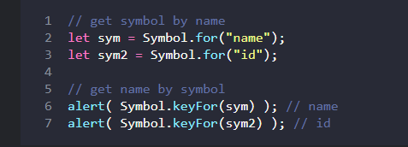

System Symbol: There are many symbols used by javaScript ans we can also use to fine tune or code

Object to primitive:
To convert objects to primitive type, js use 3 hints such as number, string and default.
String -> objects expect their key as string, so it automatically converts object to string

Number -> to perform a math operation , we some times explecitely convert the obj to number.

Math
let num = Number(obj);
let n = +obj;

Arithmetic
let result = obj1 - obj2;

Comparisons
user1 > user2
All these operations require numeric values, so JS converts objects to numbers.
Default -> Used when js doesn’t know to use a string or number.

Binary plus
obj1 + obj2
Because + can do two things:
"hello" + "world" -> string concatenation
5 + 3 -> number addition
So JavaScript uses the default hint.

How JavaScript actually converts the object?
1st check for symbol in object -> converts using symbol.toPrimitive
2nd check for String -> converts using obj.toString() or obj.valueOf().
3rd Check for number or default -> converts using obj.toString() or obj.valueOf().

Methods of Primitive:
We know that there are 7 primitive data types in js.
Can I use a method in a primitive data type?
For Eg:
str = “Hello”
str.toUpperCase(); -> here we have called a method on a primitive data type.
When we do this the js automatically creates a temporary object on the primitive, then execute the method and then destroys the object.

Internally JavaScript does something like this:
let temp = new String("hello");
temp.toUpperCase();
After the operation finishes, the temporary object is destroyed.

Numbers:
Ways to write a number -> we can use _ to make it more readable, the compiler will ignore the _ (For Eg : 1_000_000).

We can also use e to write it -> 1e6 (1_000_000)
For decimal numbers -> 0.0001 we can write it as 1e-4
Numbers can be represented in the range of 2 to 36, when using num.toString(base). By default the base is 10.
Can also use num..toString(), normally we use it like (123).toString(10).

Rounding:
Math.floor() -> rounds to the least value (Math.floor(2.7) -> 2)
Math.ceil()-> rounds to the upper most number
(Math.ceil(2.3) -> 3)
Math.round() -> rounds the number to the nearest value (Math.round(1.7) -> 2, Math.round(1.5) -> 2, Math.round(1.4) ->1).
Math.trunc() removes the digits after decimal

To round the number to the nth digit:
1.Multiply and divide
2.num.toFixed() -> returns value in a string format.

Imprecise Values:
alert(0.1+0.2 === 0.3) // false
Because every number is stored as binary digits and to store a decimal number it takes a lot of bits which will exceed the 64-bit limit.
Just like 1/3 results in 0.33333…., the decimal values also go on for too long.
Hence, js sets a limit to this values which is that it rounds the number to its nearest value.
  - -> 0.00000000000000555
So there is a value at the least bits, hence adding the number 0.1 and 0.2 will result in a different number than 0.3, but for simplicity it is represented as 0.3.

0 and -0 are two different values

Difference between isNan() and isFinite()?
Nan is a unique value, even (Nan===Nan) will result in false.
isNan(Nan) will return true, but the type of Nan is number.

isFinite(Infinity) is a number but it results in false;

The common thing between these two function is that both functions converts the input to number and check if it is true.
isFinite(“15”) -> true

Number.isNan() and Number.isFinite()
These are more stricter version than Nan, because these check the type of the input and returns the result.

Number.isNaN(value) returns true if the argument belongs to the number type and it is NaN. In any other case, it returns false.

Number.isFinite(value) returns true if the argument belongs to the number type and it is not NaN/Infinity/-Infinity. In any other case, it returns false.

Object.is() -> this function is used to check two values are equal, this is as same as ===.

parseInt() and parseFloat():
The main use of parseInt() and parseFloat() is that they check the string and convert them to number until it sees a Nan and return the value
Eg : ParseInt(120px) -> 120

